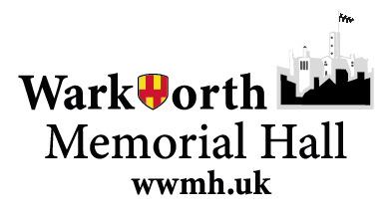
Warkworth War Memorial Hall [WWMH]

Food Hygiene Policy

Introduction
This Food Hygiene Policy outlines the standards and procedures for the safe preparation, handling, and serving of food at WWMH. The aim is to protect the health and well-being of all hall users, including volunteers, and visitors, ensuring compliance with current UK legislation and best practice.
WWMH is not a registered food business as we do not produce, store or serve food regularly as a village hall. Anyone booking the hall and employing someone i.e. paying for a food service should ensure the caterer is a registered food business. This is to be declared on the booking agreement, payment of the booking fee is considered agreement with the booking conditions.

Scope
This policy applies to all individuals and groups involved in the preparation, serving, or handling of food within WWMH, including trustees, committee members, volunteers, hirers, caterers, and event organisers.
At most events where food is provided at WWMH the food is produced, served and consumed by the hirer themselves. Appendix 1 of this policy outlines key considerations for food safety for these events; it also applies to any caterer employed by the hirer.

Legal Compliance
- All food activities must comply with relevant food safety laws and guidance.
- Those regularly preparing or serving food must be aware of and follow the Food Standards Agency (FSA) guidelines.
- Anyone booking the hall and employing someone i.e. paying for a food service should ensure the caterer is a registered food business.

Responsibilities
- WWMH Trustees are responsible for communicating this policy and ensuring all users are aware of their obligations.
- Event organisers and hirers are responsible for ensuring that anyone preparing or serving food at their event follows this policy.
- All food handlers must maintain high standards of personal hygiene and follow safe food handling practices. These are outlined in appendix 1.
- WWMH Trustees will ensure the kitchen is suitably equipped for food preparation and maintained as such.
- WWMH trustees will ensure a first aid kit is available and accessible.

Food Hygiene and Food Safety Procedures
See Appendix 1

Training
Anyone involved in food preparation or service at WWMH should follow the Key Considerations for food safety in Appendix 1, or ideally complete a recognised basic food hygiene course.
The committee will promote access to recognised online or local authority courses for those who need to access them.
High speed Training.co.uk provided Council recognised training at accessible rates.

Monitoring and Review
This policy will be reviewed annually by the WWMH Trustees or when there are significant changes in legislation or best practice. Feedback from hall users is encouraged to ensure the policy remains effective and practical.

Contact and Further Information
For questions or further guidance on food hygiene at WWMH, please contact the Hall Trustees or refer to the Food Standards Agency (UK).

Policy agreed by Trustees 07/01/2026 for review in January 2027.

