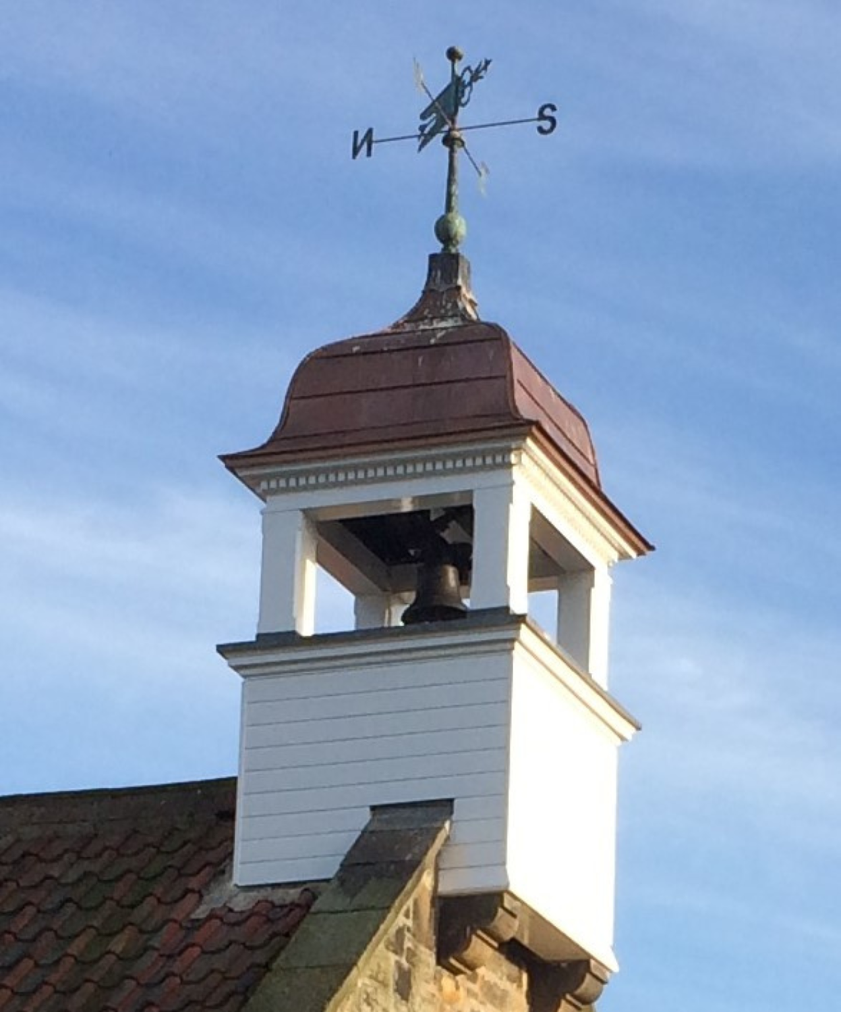  Newton on the Moor Jubilee Hall | Trustees’ Annual Report  For the year ended 31/3/2025

Table of Contents
1. Introduction and Charity Details 2
2. Structure, governance and management (Section 7.2 of guidance) 3
3. Objectives and activities (Sections 7.3 and 7.7 of guidance) 4
3.1 Charitable objects 4
3.2 Strategy framing and activities 5
4. Achievements and Performance (Section 7.4 of guidance) 7
5. Our plans for future periods 11
6. Financial Review (Section 7.5 of guidance) 12
7. Conclusion and sign off 13
7.1 Summary 13
7.2 Required legal statement on Public Benefit 13
Appendix: Accounts for period 1/4/2024 – 31/3/2025 14

- Introduction and Charity Details (Section 7.1 of guidance)

The trustees of Newton on the Moor Jubilee Hall have great pleasure in presenting our annual report for the year ended 31/3/25, which has been prepared in accordance with Charity Commission Guidance. To assist the reader, we have indicated in our report in brackets where we are making required legal disclosures.

Located in the middle of the village of Newton on the Moor, the village hall is a Grade II 17 - 19th century building comprising the main hall, a reading room, a kitchen, and associated facilities. The property is leased to a charitable organisation “Newton on the Moor Jubilee Hall”, charity number 1193440. This is run for the benefit of the community by unpaid trustees and volunteers.

Our postal address is Jubilee Hall, Newton on the Moor, Morpeth, NE65 9JY. This is our principal office. We can be contacted at notmjubileehall@yahoo.com.

Online, we can be found at: https://northumberlandvillagehalls.org.uk/newton-on-the-moor-jubilee-hall and on Facebook at: https://www.facebook.com/notmvillagehall.

At the time of preparing this report, we had the following trustees: Alison Cowen, David Arkieson, Greg Anderson, Judy Williams, and Alison Gibson. We also acknowledge the contribution of trustees who served in this financial year: Dudley Williams, Liz Rixon, and Diane Williams.

In this report, we will present a summary of how we are structured and governed, what we have achieved this year, and what we plan to do in future. We are also presenting a review of our finances, in accordance with legal requirements and our desire to operate transparently within our community.
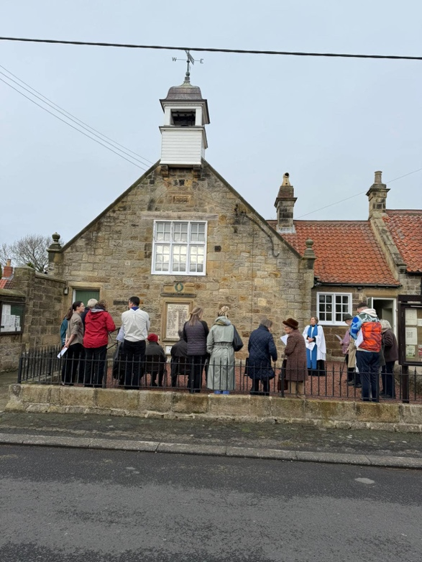
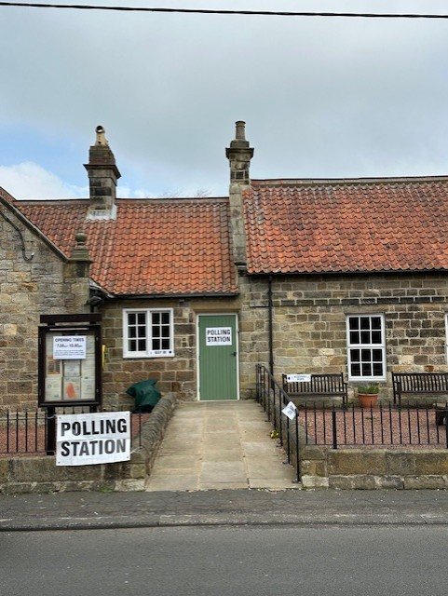
We serve as the village's polling station
The congregation for Remembrance Sunday gathered in front of the village war memorial

Structure, governance and management (Section 7.2 of guidance)

Newton on the Moor Jubilee Hall is a Charitable Incorporated Organisation (“CIO”) registered in 2021. We are governed and managed by our founding constitution, in accordance with the requirements of UK law.

Management decisions are made by the trustees, who meet regularly and publish the minutes of meetings online at: https://northumberlandvillagehalls.org.uk/newton-on-the-moor-jubilee-hall/documents.

During the course of this year, we updated and published our Health and Safety, Equality, Finance, Privacy, and Safeguarding polices at the same web address.

As a CIO, we maintain accounting records, and we prepare our accounts on a receipts and payments basis. While no external scrutiny of our accounts is mandated by law, the trustees believe it is good practice for this to be done. Accordingly, the accounts were reviewed by David Cant, a retired ACCA accountant, on April 16th. No issues were identified.

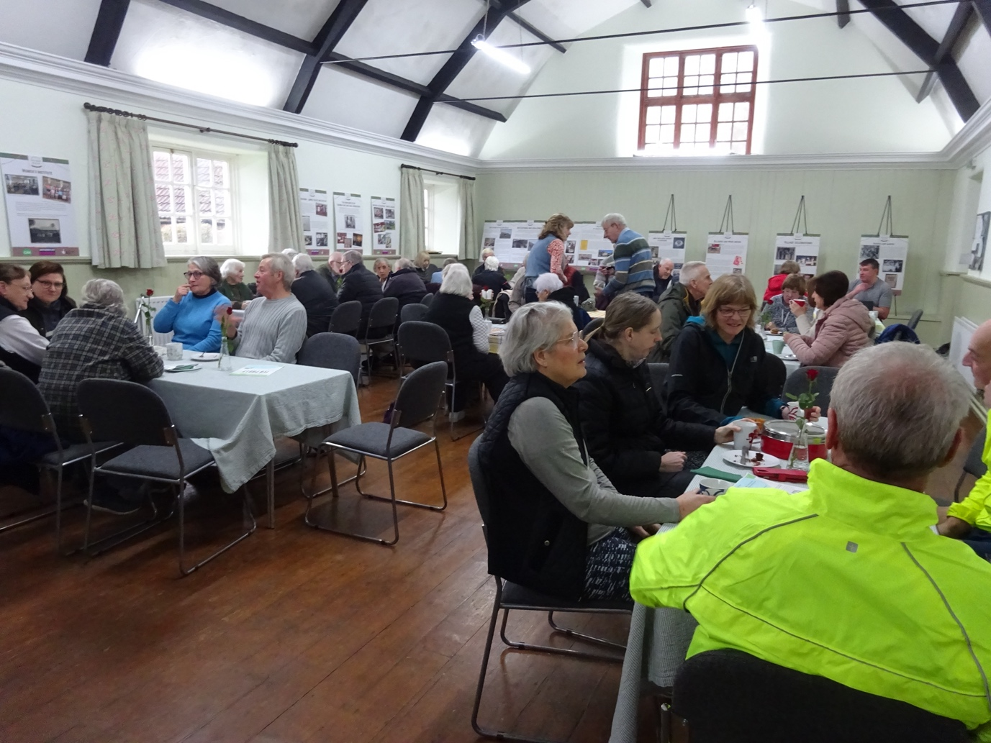
The village hall “in action” at one of our monthly coffee mornings. On average, 52 people attended our coffee mornings this year.

3. Objectives and activities (Sections 7.3 and 7.7 of guidance)

3.1 Charitable objects

Our objects were defined when we registered as a CIO with the Charity Commission as:

“…to establish and run a village hall and to promote for the benefit of the inhabitants of Newton on the Moor within the parish of Newton on the Moor and Swarland without distinction of sex, sexual orientation, age, disability, nationality, race or political, religious or other opinions the provision of facilities for recreation or other leisure time occupation of individuals who have need of such facilities by reason of their youth, age, infirmity or disablement, financial hardship or social and economic circumstances or for the public at large in the interests of social welfare and with the object of improving the conditions of life of the said inhabitants.”

3.2 Strategy framing and activities

In the course of the year, we developed a strategy framing to guide us in achieving our objects and in discharging our obligation to deliver public benefit:

Our Vision

We aim to be:

- A resource for the community of Newton on the Moor, surrounding areas, and the wider society, where community members can gather for recreation, socialisation, entertainment, and general wellbeing
- A hub for residents to access support in the event of local emergencies
- Here in 100 years’ time to meet the needs of future generations

Our Mission (Our activities)

Here is what we will do:

- M1 Provide a safe, well-presented and clean, warm, and welcoming space
- M2 Equip the hall with modern amenities
- M3 Develop and deliver a programme of events and activities to meet the needs of the community for socialising and entertainment, and to promote health and well-being
- M4 Be available to rent for community groups at the lowest possible cost
- M5 Marshal and manage resources and funding to maintain the hall, cover its operating costs, and secure its future
- M6 Discharge our responsibilities under the terms of the lease held on the hall
- M7 Anticipate, and plan for, future factors that will impact operations

Our Values

These are the principles we will apply as we carry out our mission:

- V1 Openness and accountability: the trustees will disclose how our funds are raised and spent, and publish our meeting minutes.
- V2 Focus on mission: the trustees will apply our efforts and resources to delivering our mission
- V3 Efficient use of resources: the trustees will aim to achieve the highest possible social impact with the available resources
- V4 Being cost efficient: trustees will use volunteer labour where possible to minimise expenditure, and reduce energy usage and costs.
- V5 Sustainability: We aim to maintain the financial health of the CIO, and apply environmentally friendly practices
- V6 Inclusiveness: We welcome all community members, without distinction of sex, sexual orientation, age, disability, nationality, race or political, religious or other opinion
- V7 Legal compliance: We comply with all relevant UK legislation relating to events, health and safety, and our charitable status

4. Achievements and Performance (Section 7.4 of guidance)

The last financial year has been a busy one, and our focus has been on bringing hall facilities up to the standards required for a public building and community venue. We have summarised our key achievements below against our agreed mission:

- Space Provision

We installed smoke detectors and a carbon monoxide monitor, obtained our food safety certificate (at Level 5). We had our electricity box inspected and brought up to standard for a public building. All our electrical equipment was PAT tested. Our gas boilers were inspected, and safety certificates were issued. Our fire extinguishers were maintained.
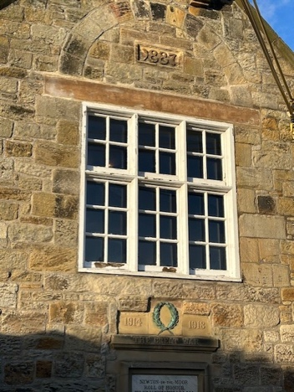
We completed the renovation of the fireplace in the reading room, repaired the roof, replaced rotten sash windows in the reading room, and repaired the lintel over the window on the front of the hall.

The walls in the main hall were painted. We installed a smart gas meter, and we replaced the lights in the main hall and the reading room with LEDs to reduce energy consumption. We reviewed our cleaning arrangements.

Much of the maintenance work on the hall has been done by unpaid volunteers, allowing us to spend our limited funds wisely on specialist labour where needed.

The new lintel over our window facing the road

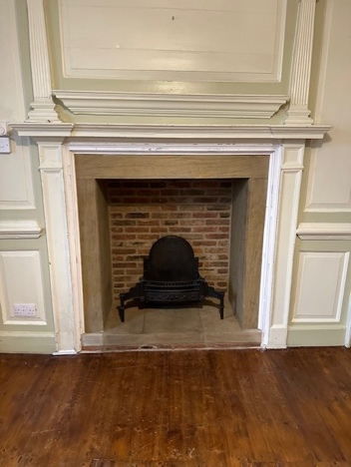
...and after it was restored
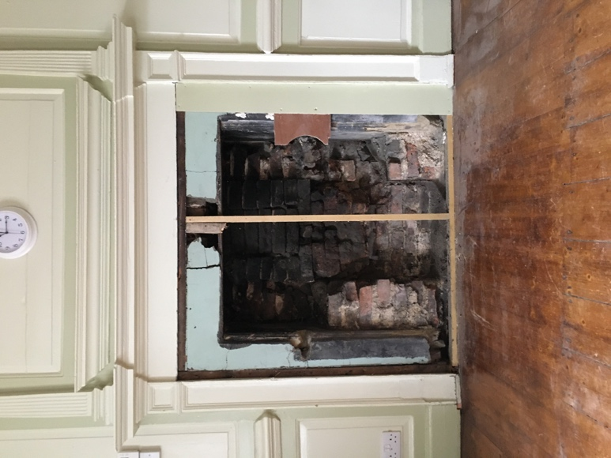

The Georgian fireplace before....

- Amenities provision

We installed fibre internet at the hall and created a free network for visitors to use. We began to take bookings for the use of the hall, and to publish our availability, online. Bookings are taken here: https://northumberlandvillagehalls.org.uk/newton-on-the-moor-jubilee-hall/booking.

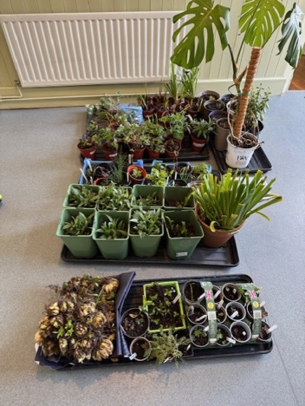
One of our coffee mornings featured a sale of plants, and many attendees bagged a bargain!

- Events and Activities

We held eleven coffee mornings for the community in this financial year, with seasonal themes, and have begun publishing our programme six months in advance.

At our coffee mornings, we have been providing IT help for attendees, and have had visits from Alncom, Community Action Northumberland, the Digital Champion, and the Greater Northeast Air Ambulance.

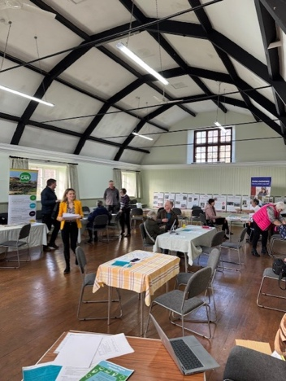
We hosted our first “Techie tea party” to support local residents with their IT.
Our “Techie Tea Party” was well attended and five people received personalised help with their IT issues

We hosted the carpet bowls club, music groups (Northumbrian pipes, fiddle players, French music, the Coquet Concert Band), acts of religious worship, clog dancing, meetings of the Parish Council and its Planning subgroup, a church tea, three community funerals, a birthday party, and a community meeting. We participated in the launch of the “Heritage of Northumberland Village Halls” book.

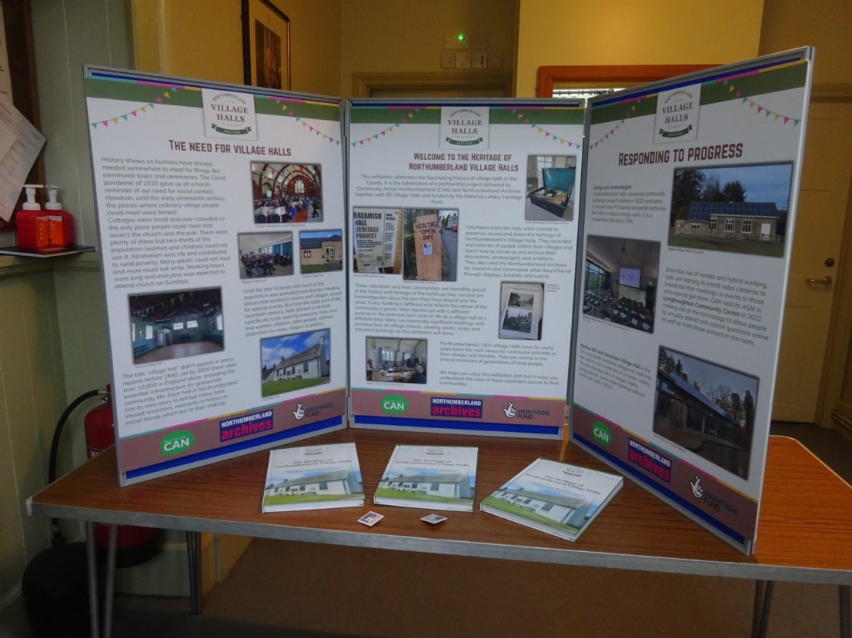
Launching the book which charted the history and social significance of village halls in Northumberland, including ours.
To identify any unmet needs the community may have, we conducted a survey of Newton on the Moor residents to determine their opinions and how they would like to use the hall. As a result of this, we are explored options for a book club, gardening, history, food-related events, and craft workshops. Our events programme for next year includes these new events.

- Community venue

Our hall was used as the location for filming, for which we received a donation of £8,000. Local people participated as film extras and local residents were paid for services during filming. We hosted a drinks party for the community after completion of the filming.

We were all sworn to secrecy as a film crew shot scenes for a movie by an Academy Award winning director

We were available to rent for community groups at a fee of approximately £12.50 per hour this year, with discounts for the community. This yielded an income of £2,404.00 in the financial year ended 31/3/2025.

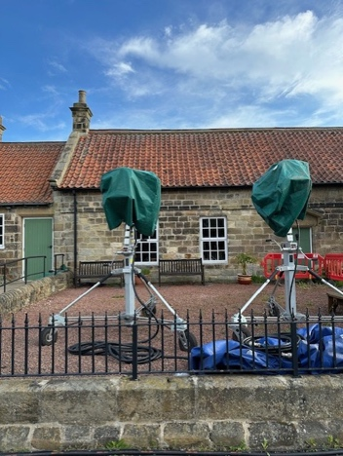
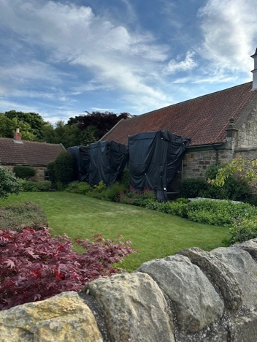
- Resources and funding

We published a financial policy. We met to create and review a business plan, and set budgets for next financial year. We agreed to create a financial reserve of £8,000 as a provision against future risks, and likely expenditures. This reserve is to be held in an interest-bearing account to mitigate the effects of inflation.

- Lease

Our lease on the hall building was drafted in 1966 and is no longer fit for purpose. We have agreed a course of action with the landlord to revise the lease, and have taken legal advice.

- Future Focus

We evaluated whether a lottery programme to raise funds for the hall would be viable, and came to the conclusion that it was not. We agreed to explore further fundraising opportunities to offset operating costs and potentially raise funds for improvement projects. We applied to the National Lottery and other funding bodies for funds for a new roof, and were refused because our governance is not formalised. We identified the steps needed to improve our governance, and have included actions in next year’s plans to bring our governance and facilities up to the required standards to be able to apply for grants.

Our plans for future periods

As a small group of volunteers and trustees, we met to discuss our plans for the next financial year to meet our charitable objects and deliver on our mission. We agreed a short list of priority actions which we plan to carry out before 31/3/2026:

- Actions needed to achieve Hallmark status
- Actions needed to achieve Warmhub status
- Conduct Warmhub energy efficiency review
- Solar Panel feasibility study
- Update and sign new lease
- Repaint hall ceiling
- Refresh toilets, paint entrance and door in Reading Room
- Evaluate feasibility of becoming a Community Response Hub
- Develop a plan for wildlife at our location
- Develop measurement framework (efficiency & impact) for our CIO

Actions 1 and 2 will bring our hall into line with the standards of other village halls in the county, and are a pre-requisite for accessing grant funding. Actions 3, 4 and 9 are targeted at improving our environmental sustainability. Further, actions 3 and 4 may help us reduce our energy bills. Action 5 will re-formalise our relationship with our landlord and bring our lease into compliance with modern legal frameworks. Actions 6 and 7 will improve the appearance and attractiveness of the hall. Action 8 aims to meet the needs of the Community in the event of bad weather or local emergency. Action 10 will improve our ability to explain how we have met our charitable objects and delivered public benefit.

Financial Review (Section 7.5 of guidance)

In the financial year 1/4/2024 – 30/3/2025, we received £17,059.69 in income, and our expenditure was £13,373.39. Overall, we generated a surplus of £ 3,676.30. As at 31/3/2025, our assets comprised £19,381.29 in cash. A breakdown of these figures is presented in the Appendix to this report.

As a CIO, our financial goal is to cover the costs of our activities, and we are not seeking to make a “profit” as such. This year saw a large donation for the use of the hall for filming purposes, and we held an event for the local community immediately after the period during which we were closed, to provide a public benefit. This was a one-time occurrence and is highly unlikely to be repeated in future years.

Our largest sources of income were our receipts from our monthly coffee mornings (£3,104.03), grants of £2,618.00 (including £2,000 this year from the Parish Council), and our income from hall hire (£2,404.00).

Our largest expense for the year was on maintaining our historic building. We spent £3,427 on refurbishing the fireplace, £1,033 on window repairs, and £1,288 on repairs to the roof.

As at 31/3/2025, the CIO has no outstanding guarantees and has no debt (Section 4.5 of guidance).

Over the course of the year, the trustees decided to establish and maintain the following cash reserves:

 |  |  | £ | Purpose
1. Emergency reserve |  | 1,000 |  | To cover unexpected expenses for items requiring immediate attention
2. Income interruption reserve |  | 5,500 |  | As a safeguard against having to shutter the hall for a period (such as we did during Covid). To be used in the event we have no income but still need to cover hall costs
3. Reserve for future projects |  | 500 |  | To cover capital expenses which may reasonably be expected in next 5 years (new boiler)
4. Operating reserve (Reserve for cash fluctuations) |  | 1,000 |  | To cover timing differences in case income is delayed or unpredictable.
 | Total reserves to be held | 8,000

We will be reviewing our reserves on an annual basis to ensure they are appropriate to the emerging risks and our anticipated needs.

This year for the first time, we prepared an annual business plan and budget for the forthcoming financial year, as a tool to guide and track our activities. Reporting on our progress against plan and budget has been added as a standing item on our trustee meeting agenda.

Conclusion and sign off

7.1 Summary

Our activities this year have been focussed on upgrading our hall facilities to bring them into compliance with health and safety legislation, and contemporary expectations about what village hall ought to be in 2025. We have aimed to preserve the character of our Grade II listed building as we have been making changes.

We have worked on our governance, management and forward planning.

We believe that we are now better positioned to achieve our objects. We have a plan to further upgrade our facilities, and expand the programme of events we offer the community.

7.2 Required legal statement on Public Benefit (Section 7.7 of guidance)

The trustees also confirm that they have complied with their legal duty with regards to public benefit, as defined by the Charity Commission, in the discharge of their duties.

Signed on 14/06/2025

Alison Cowen
Chair of trustees

Appendix: Accounts for period 1/4/2024 – 31/3/2025

Charity Commission webpage accessed 25/5/2025 https://www.gov.uk/government/publications/charity-reporting-and-accounting-the-essentials-november-2016-cc15d/charity-reporting-and-accounting-the-essentials-november-2016-cc15d--2#section4

