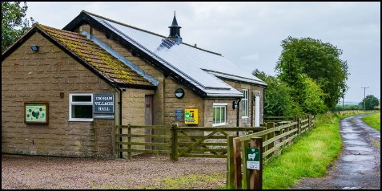
APPLICATION TO HIRE INGRAM VILLAGE HALL

Name of Organisation/Organiser
Purpose of the hire (party, meeting, fund raiser, etc)
Name of contact person
Email Address
Phone Number | Day |  | Evening
Booking Info | One off/Regular (please delete as applicable). If regular please provide frequency:
Date of Booking
Time of Booking | FROM: TO:
Will the hall be used for commercial purposes? (ie for profit) | Yes/No (please delete as applicable)
Is the organisation insured for the proposed activity? | Yes/No (please delete as applicable)
If Yes – name of insurer & amount of public liability
Insurance Policy No (if applicable)
Does the organisation work with under 18s | Yes/No (please delete as applicable)
If Yes – do those people leading the activity have the appropriate checks in place, ie DBS checked. | Yes/No (please delete as applicable)
Will alcohol be consumed and by what arrangements? | Yes/No (please delete as applicable)  If yes please complete below:  Bring your own/pay bar (please delete as applicable)  If you are having pay bar, you must apply to Northumberland County Council for a Temporary Events Notice. We will require sight of the notice prior to the event going ahead.
Do you require wifi access?  Wifi code displayed in hall | Yes/No (please delete as applicable)

Please note, that while the Trustees of Ingram Village Hall make every effort to ensure the safety of all who use its premises, your organisation will be solely responsible for premises, equipment, personnel and its activities during the period of your booking
“Your personal data
Your information will only be used by us to process your application, to communicate with you regarding your application and to send you information regarding Ingram Village Hall. We will only send you relevant information. We will never sell your information to any third parties.

I have read and agree to abide by the Condition of Hire (please retain a copy)
Signed: | Date:

HIRE CHARGES
Individual/one-off booking/Organisations | £10.00 per hour
Regular/ community users upto a max of £50 for 24 hours | £8.00 per hour
Party booking | Please contact Helen Wyld
Overnight booking | £50/night

Please return completed form to:
Email: newmoorhouse@yahoo.co.uk

Post: Keepers Cottage,
Reaveley Westside,
Powburn,
Alnwick.
NE66 4LS

