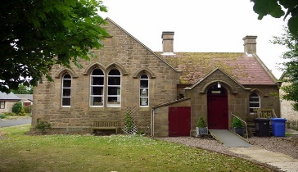

Agenda - CVH Committee – 13th June 2022 – 10.30am

- Apologies
- Minutes of last meeting
- Matters arising
- Election of officers
- Treasurer's report
- Assignment of responsibilities
- Keys
- Bar
- Events
- AOB
- Date of next meeting – 11th July 2022

