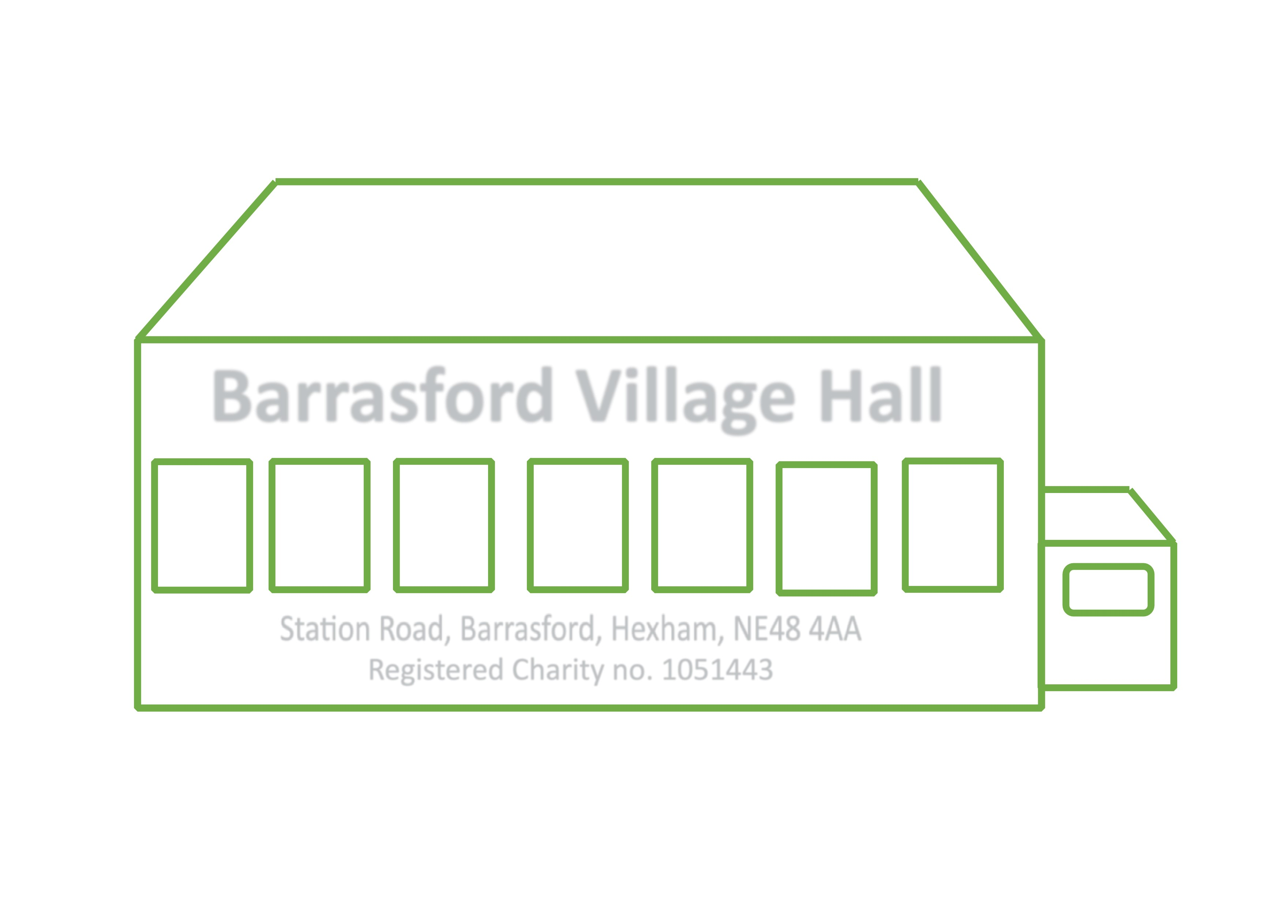
Barrasford Village Hall - Environmental Policy

Barrasford Village Hall committee is committed to protecting and actively promoting the improvement of the local environment.

The committee will ensure that environmental priorities are integrated into the decisions it takes on all of its services and will seek to:

- Make the most efficient use of energy. It will endeavour to use the minimum quantities of energy possible in accordance with the safe and efficient operation of its heating, lighting, plant, and machinery. It will from time to time review its energy sources, energy using appliances and energy efficiency with a view to causing the least environmental impact. It will monitor consumption and eliminate excessive or unnecessary use. It will communicate to hirers, volunteers, and staff how energy may be conserved, e.g., closing doors, ensuring heaters are switched off at the end of each hire session.

2) Where possible encourage those using the hall to walk, cycle and use public transport
as alternatives to the private car. It will seek to provide information about public
transport on publicity materials and encourage car sharing.

3) Minimise and where possible eliminate all forms of pollution, using biodegradable
chemicals where possible, and minimising use of solvents and lead-based paints. Users
will be encouraged to avoid creating noise and light pollution, especially at night.

4) Use the minimum quantities of water possible in accordance with its activities and
ensure that the water it uses is both supplied and disposed of, in the purest condition
possible, meeting statutory requirements. It will reduce leakage and eliminate
excessive or unnecessary use, e.g., through avoiding unnecessary flushing of urinals
when the hall is not in use. It will communicate to users and staff the need to conserve
water e.g. turning off taps.

5) Avoid waste and encourage the appropriate conservation, re-use, and recycling of
resources. It will re-use and recycle materials as far as possible and, if this is
impractical, disposal by a means which will have the least impact on the environment
and conforms to statutory requirements. It will encourage users and staff to minimise
waste, including the provision of separate disposal facilities for recycling glass, plastic,
tins and cardboard / paper.
NOTE: It would not be compliant with the committee’s duty of care
or the government recycling requirements to ask hirers using the hall for occasional domestic and fundraising and other similar events to dispose of the waste generated
on the premises themselves.

6) It will ensure that the potential environmental impact of any building projects will be
assessed and minimised. This will include, where possible, methods of construction
which make best use of resources; designs which result in low maintenance and high
energy efficiency and the use of building materials from sustainable sources such as
timber. It will encourage volunteers, hirers, and staff to use and operate the building
correctly to conserve energy and minimise waste.

7) It will seek, where possible, to purchase from local or regional suppliers, to maximise
input to the local community and minimise carbon emissions from transport.

8) It will work to enhance its outside space where feasible to improve biodiversity (e.g.
planting trees/flowers/shrubs to provide pollen/berries/fruit for wildlife).

9) Encourage Hirers to think about the resources they use and avoid single use plastics
and food waste.

10) Protect the health and well-being of all volunteers, staff and visitors and improve and
safeguard the quality of Barrasford Village Hall.

11) Monitor, review and where possible improve performance each year with positive
action on any areas of non-compliance.

This policy was adopted by Barrasford Village Hall
On 6th May 2025 ..............................................
Date to be reviewed May 26....................................

Name ..............................................

Signed

