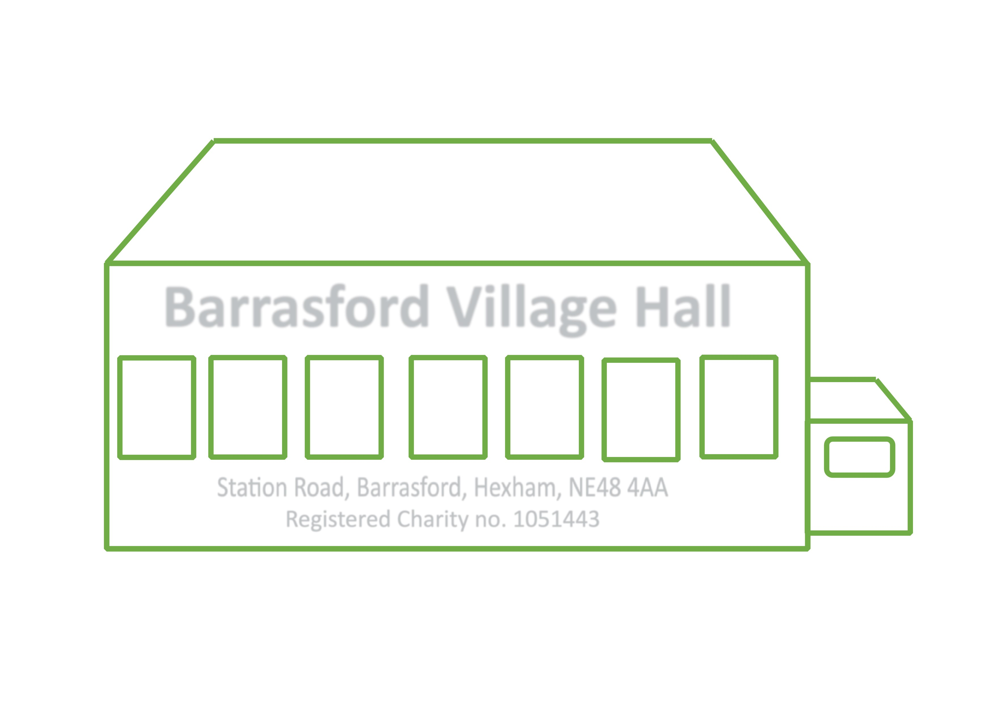
Barrasford Village Hall
Safeguarding and Child and Vulnerable Adults Policy

Barrasford Village Hall committee is committed to safeguarding and promoting the welfare of children, young people and vulnerable adults engaged in activities delivered from its premises. Barrasford Village Hall committee believes that it is unacceptable for a child or young person to experience abuse of any kind and recognise its responsibility to safeguard the welfare of all children, young people and vulnerable, by a commitment to practice which protects them.

Safeguarding is everyone’s responsibility.

We recognise that:
• the welfare of the child/young person/vulnerable adult is paramount
• all children, young person or vulnerable adult, regardless of age, disability, gender, racial heritage,
religious belief, sexual orientation or identity, have the right to equal protection from all types of
harm or abuse
• working in partnership with children, young people, vulnerable adults, their parents, carers and
their agencies are essential in promoting young people’s welfare.

The purpose of the policy is:
• To provide protection for the children, young people and vulnerable adults who use Barrasford Village
Hall including the children of adult members or users.
• To provide volunteers with guidance on procedures they should adopt in the event that they suspect a
Child, young person or vulnerable adult may be experiencing, or be at risk of, harm.
- To provide committee members, staff and volunteers with guidance on protection they should adopt in the event that they suspect a child, young person or vulnerable adult may be experiencing, or at risk of harm.

Some children/ vulnerable adults with special educational needs, who are neurodiverse or have an illness may be more vulnerable to exploitation, harm or abuse. Abuse may consist of a single act of repeated acts. It may be physical, verbal or psychological, it may be an act of abuse/neglect or an omission to act.

The Department of Health in its ‘no secrets’ report suggests the following as the main types of adult abuse –
- Physical abuse – including hitting, slapping, pushing, kicking, misuse of medication, restraint, or inappropriate sanctions
- Sexual abuse – including rape and sexual assault or sexual acts to which the child / vulnerable adult has not, could not or was pressured into consenting
- Psychological abuse – including emotional abuse, threats of harm or abandonment, deprivation of contact, humiliation, blaming, controlling, intimidation etc
- Financial or material abuse – including theft, fraud, exploitation, pressure in connection with wills, property or inheritance or financial transactions, or the misuse or misappropriation of property, possessions or benefits
- Neglect and acts of omission – including ignoring medical or physical care needs, failure to provide access to appropriate health, social care or educational services, the withholding of the necessities of life, such as medication, nutrition and heating
- Discriminatory abuse – including racist, sexist acts, based on a person’s disability, age or sexuality and other forms of harassment, slurs or similar treatment

We will seek to safeguard children, young people and vulnerable adults by:
• valuing them, listening to and respecting them
• adopting guidelines through procedures and a code of conduct for volunteers
• recruiting volunteers safely, ensuring all necessary checks are made
• sharing information about safeguarding and good practice with children, vulnerable adults, parents,
volunteers, committee members and user groups
• sharing information about concerns with agencies who need to know, and involving parents and children
appropriately
* ensuring that the venue is a safe environment in line with our Health and Safety Policy
* maintaining appropriate insurance for all activities

We are committed to reviewing our policy and good practice annually in May of each year, or more frequently as required by changes in law, guidance or good practice.

Procedure in the event of a disclosure or suspicion of abuse –

It is recognised that a child/vulnerable adult may seek people out to share information about abuse or neglect, or talk spontaneously individually or in groups when you are present. In these situations, You Must –
- Listen carefully to them, giving them time and attention. Do Not directly question them
- Allow them to give a spontaneous account, do not interrupt them when they are freely recalling significant events
- Make an accurate record of the information you have been given taking care to record the timing, setting and people present, their presentation as well as what was said.
- Use their own words where possible
- Explain that you cannot promise not to speak to others about the information they have shared – do not offer false confidentiality
- Reassure them that they have done the right thing in telling you and that they have not done anything wrong
- Tell them what you are going to do next and explain that you will need to get help to keep them safe
- Do Not ask them to repeat their account of events to anyone
- Report the disclosure immediately to the Designated Safeguarding Lead.

Procedure in the event of a concern -
In the event of a concern about a child or vulnerable adult, You Must –
- Make an accurate record of the concern taking care to record the timing, setting, people present, their presentation as well as anything that was said. Do not throw this away as it may be needed later for evidence
- Do Not make assumptions
- Do Not investigate the concern
- Report the concern immediately to the Designated Safeguarding Lead (DSL)

Reporting -
Any suspicion, allegation, incident, abuse or disclosure must be reported immediately to the Designated Safeguarding Lead (DSL) for this organisation (details below) who will make a decision on any actions required.

Safer recruitment –
All staff, working directly for the village hall must –
- Complete an application form which shows their employment history
- Provide at lease two references
- If working directly with children, young people or vulnerable adults – one of the references should come from someone who has supervised them working with children, young people or vulnerable adults before, and they will be checked under the disclosure and barring service (DBS)

All volunteer’s working for the village hall committee and have unsupervised access to vulnerable users e.g. children’s entertainer, may also be required to go through these processes.

Currently the village hall does not employ staff. Volunteers who clean the hall do not have contact with the groups or individuals using the hall and consequently do not need DBS checks. If conditions change for these or future users each post will be assessed and any checks carried out accordingly.

Code of behaviour for paid staff and volunteers –
- Safeguarding of all hall users is a shared responsibility for trustees, committee members, volunteers
- All volunteers are expected to familiarise themselves with the halls Safeguarding policy and procedures and will each receive a copy.
- All hall users are expected to be familiar with expectations of behaviour when working with children, young people and vulnerable adults including –
- Respecting privacy and preserving dignity at all times
- Avoiding physical contact other than necessary for the care of individuals and being aware of what is acceptable for them.
- Knowing that all forms of verbal abuse, aggression or manipulated behaviour are totally unacceptable, refraning from such acts and reporting any infringements.

Whistleblowing policy -
- Any individuals making a referral will be protected by the committee under the whistle blowing procedures, similarly if the individual making the referral feels that insufficient action / follow up has taken place they should inform the committee without the fear of repercussion.
- The procedure for whistle blowing includes –
- Protecting those who make the referrals under the whistle blowing procedures is that there is a culture of informing without reprisal or negative consequences.
- As far possible protecting the anonymity of the whistle blower, except where so doing could endanger another individual.
- Thoroughly investigate any reported incidents regardless of how unlikely they seem.
- Keeping accurate records so that any patterns in behaviour can be monitored.

Keeping staff / committee members / volunteers / up to date with safeguarding
- All staff / Committee / volunteers will receive a copy of all policies when they are appointed as staff / join the committee or volunteer. The designated safeguarding lead will go through the policies and procedures when they receive them to make sure they understand them and know what to do if there is any situations.
- All policies are renewed every year at a committee meeting so everyone understand them.
- This safeguarding policy may be amended at a committee meeting if there are major changes to
legislation for example ‘working together to safeguard children, 2018’
- Staff / committee members / volunteers are encouraged to attend safeguarding training when it
becomes available to them.
- The DSL will renew their training annually through her full-time job to stay up to date with relevant
changes.

In the event that the DSL is not available support should be sought from the chair of the committee Richard Haycock, 07768862914 or the children’s social care locality team via ONECALL: 01670 536400 (open 365 days a year, 24 hours a day). In an emergency, please call 999 and make a report to the Police.

The Designated Safeguarding Lead (DSL) is Gemma Nixon and she may be contacted on (01434) 689737 / 07854633990.

This policy was adopted by Barrasford Village Hall

On ..............................................

Date to be reviewed ....................................

Name ................................................

Signed ……………………………………………..

