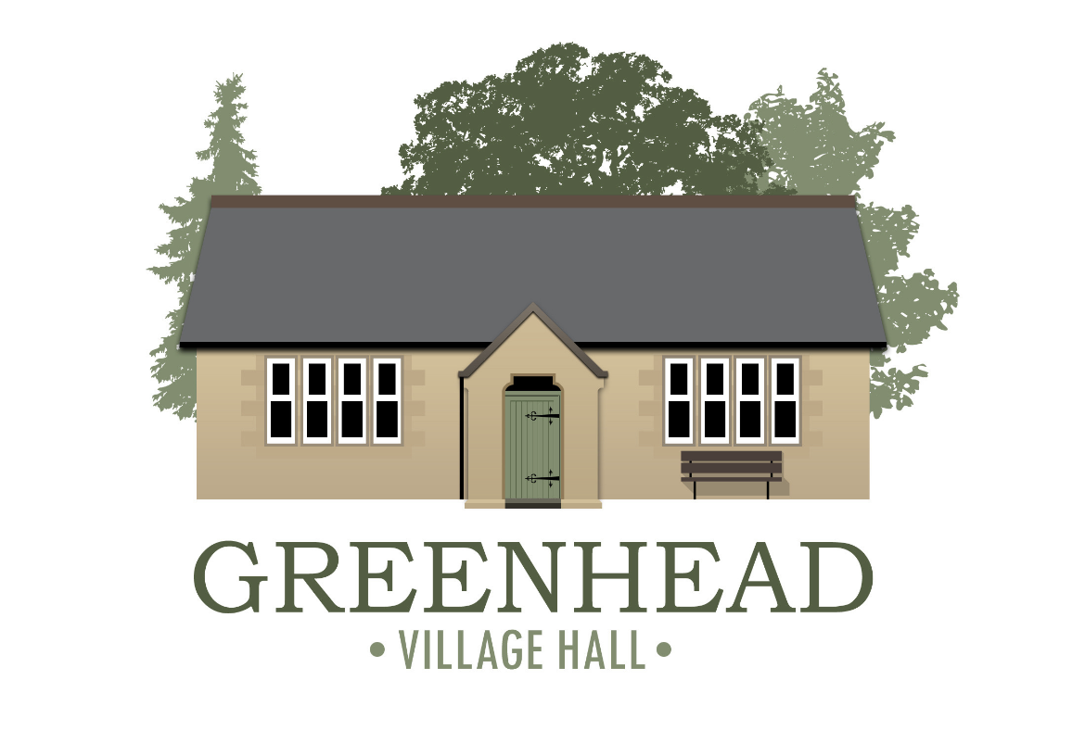
Registered Charity No 1077054

Chairman | Vice-Chair | Treasurer | Secretary
Alan Sharp  Email:  alan.sharp@galbraithgroup.com | Howard Maxted  Email: howardmaxted@gmail.com | Gary Switzer  Email: garys_home@yahoo.co.uk  Tel: 07931440075 | Emma Switzer  School House, Greenhead, Brampton  CA8 7HB  Tel: 07525021721  Email: ms.em.dixon@gmail.com

GENERAL MEETING MINUTES
Greenhead Village Hall Management Committee
Monday 16/09/2025 7.00pm
ITEM | DESCRIPTION | ACTION TO BE TAKEN
1 | WELCOME FROM THE CHAIR: Welcome and thanks for attendance from AS.
2 | PERSONS PRESENT: Alan Sharp, Emma Switzer, Gary Switzer, Jude Clark, June Longstaff, Howard Maxted.
3 | APOLOGIES FOR ABSENCE: Helen Myers, Jenny Wheeler.
4 | MINUTES OF PREVIOUS MEETING: 30/06/2025 attached are approved.
5 | MATTERS ARISING:  - Insurance claim update for damage to Village Hall by van. Works completed Notice board in situ. All trustees are happy with the work carried out.  - Recent and upcoming bookings.  - Poetry sessions still running  - Harvest Supper  - Mammas Circle  - Aerial Acrobatics class  - PVMC Club have booked for July 2026  - Men's urinals, all works now complete. Thanks to trustees and Richard Pattinson.  - Cooker purchase still outstanding. Must get to Westgate hardware and order.  - Decorating village hall outside - Parish council have agreed the estimate, is it too late in the year to start? June will contact him.  - A Frame Boards: Howard will go to top signs and find out what they can do for us.  - Oil top up. Gary will order. Howard will also look at costing the oil level monitor.  - Invoicing should be up to date now, and next quarters invoice will be issued shortly where applicable.
6 | CORRESPONDENCE: None
7 | APPOINTED REPRESENTATIVES UPDATES:  Farmers Market: Fluctuating numbers, new paintings stall. The market is 20 years old now.  Arts, Crafts and Calico Hinnies: Craft only has 3 members now. Needs some more advertising. Calico Hinnies doing well. Art is fine.  St Cuthbert's Church: Numbers up to 6 last week. Cream teas did well. Harvest Festival (on 28th also breakfast club(no Howard)) and supper.  Women's Institute: Jenny absent  Parish Council: Asset register for Notice board - trustees agreed that as the board was mostly repaired its value would not have changed. Defibrillator: Will need an upgrade next year. Look into how to fund this. possible grants etc, between parish and village hall.
8 | FINANCIAL REPORT:  Need to get some funding as we are 3k down on this time last year. We have had a lot of capital outlay.  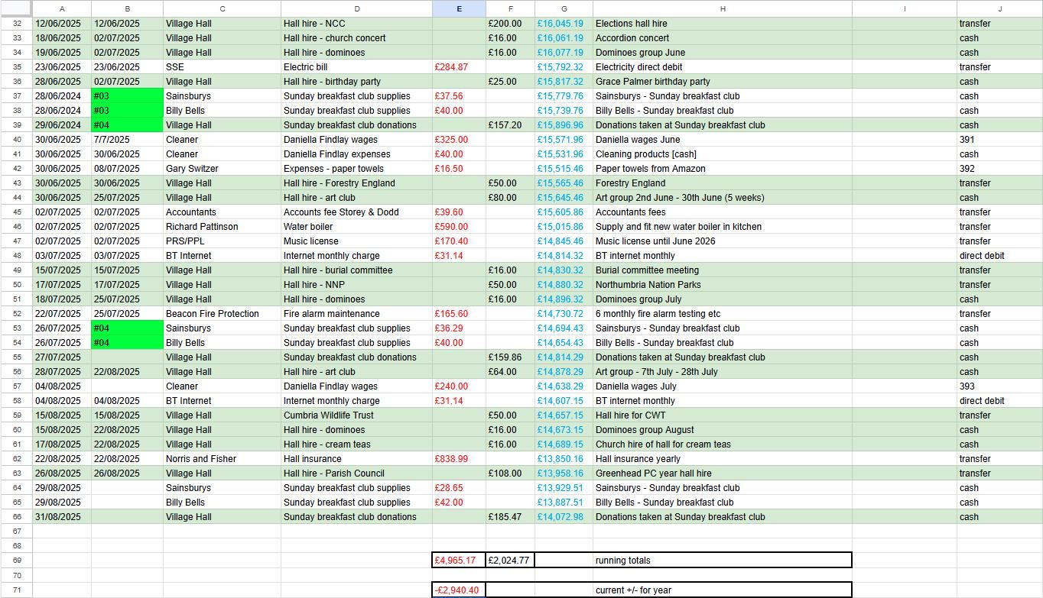
9 | EXPENSES TO APPROVE:  £10.99 GS additional ingredients for Breakfast club  £5.00 ES A4 paper  £13.99 HS Dishwasher tablets
10 | A.O.B:  FUNDING:  For: Cooker, Water heater, Benches, A frame boards, Mugs/crockery, more tongs and oven gloves, kitchen equipment. New Chairs.  Smith Trust - Helen Myers to apply  Community Shop Fund  Fundraising Event for the Hall. Bingo!!!! Ask Jenny to ask Phil Garrington if he can do one in November.  Christmas Carols round the tree - 17th December. AS will pay for the tree. Raffle
11 | DATE AND TIME OF NEXT MEETING:  20th October 2025 6.30pm AGM with GM to follow at 7pm | Notice on boards, website and social media.
12 | MEETING CLOSED:  20.28pm

