Health and Safety Policy for Barrasford Village Hall (11/6/18)
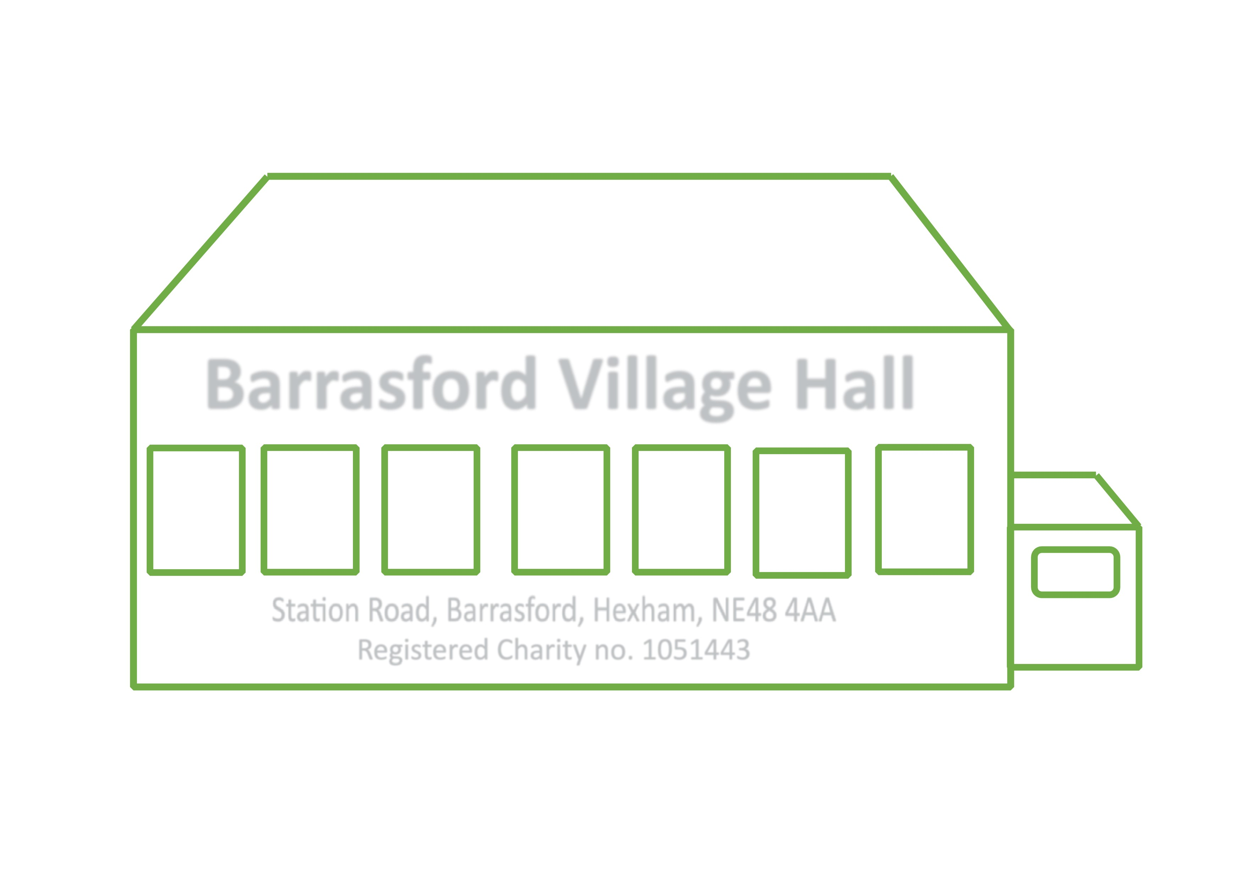

Part 1 General Statement of Policy

This document is the Health and Safety Policy of Barrasford Village Hall.

Our policy is to:

- Provide healthy and safe working conditions, equipment and systems of
work for our volunteers, committee members and hirers.

- Keep the village hall and equipment in a safe condition for all users.

- Provide such training and information as is necessary to staff, volunteers and users.

It is the intention of Barrasford Village Hall Management Committee to comply with all health and safety legislation and to act positively where it can reasonably do so to prevent injury, ill health or any danger arising from its activities and operations.

Barrasford Village Hall Management Committee considers the promotion of the health and safety of its volunteers and those who use its premises, including contractors, who may work there, to be of great importance. The management committee recognises that the effective prevention of accidents depends as much on a committed attitude of mind to safety as on the operation and maintenance of equipment and safe systems of work. To this end, it will seek to encourage employees, volunteers, committee members and users to engage in the establishment and observance of safe working practices.

Volunteers, hirers and visitors will be expected to recognise that there is a duty on them to comply with the practices set out by the committee, with all safety requirements set out in the hiring agreement and with safety notices on the premises and to accept responsibility to do everything they can to prevent injury to themselves or others.

Signed: (On behalf of the Management Committee)

D Haycock

Name D Haycock

Position Secretary

Date 6/5/2025

Part 2: Organisation of Health and Safety

The Barrasford Village Hall Management Committee has overall responsibility
for health and safety at Barrasford Village Hall.

The person(s) delegated by the management committee to have day to day
responsibility for the implementation of this policy is/are:

Name Richard Haycock
Telephone Number 01434 681877
Address Green View
Barrasford
Hexham
NE48 4AA

Name Ian Lancastle Smith
Telephone Number
Address 7 Chishillways
Barrasford
Hexham
NE48 4AE

It is the duty of all volunteers, hirers and visitors to take care of themselves and others who may be affected by their activities and to co-operate with the management committee in keeping the premises safe and healthy, including the grounds.

Should anyone using the hall come across a fault, damage or other situation which might cause injury and cannot be rectified immediately they should inform the person(s) above, or the Bookings Secretary, as soon as possible so that the problem can be dealt with. Where equipment is damaged a notice should be placed on it warning that it is not to be used and it should be placed in the Supper Room store.

The following persons have responsibility for specific items:

First Aid Box Deb Haycock

Reporting of Accidents The Committee

Fire Precautions and checks The Committee

Risk assessment and inspections Dick Haycock

Information to contractors Dick Haycock / Ian Lancastle Smith

Information to hirers Elissa Patterson

Insurance Linda Davies

Appendix A shows a plan of the Hall detailing the location of fire exits, fire extinguishers, fuse box or distribution board, stop cock, loft access.

Part 3 Arrangements and Procedures

3.1 Licence
The village hall has a Premises Licence authorising the following regulated entertainment and licensable activities at the times indicated:

Activity | The Hall is licensed for | Times for which the activity is licensed
(a) The performance of plays | No
(b) The exhibition of films | No
(c) Indoor sporting events | No
(d) Boxing or wrestling entertainment | No
(e) The performance of live music | Yes | Monday to Friday 9am to 1am  Saturday & Sunday 9am to Midnight
(f) The playing of recorded music | Yes | Monday to Friday 9am to 1am  Saturday & Sunday 9am to Midnight
(g) The performance of dance | Yes | Monday to Friday 9am to 1am  Saturday & Sunday 9am to Midnight
(h) Entertainment similar to those in (a) to (g) | Yes | Monday to Friday 9am to 1am  Saturday & Sunday 9am to Midnight
(i)Making music | Yes | Monday to Friday 9am to 1am  Saturday & Sunday 9am to Midnight
(j) Dancing | Yes | Monday to Friday 9am to 1am  Saturday & Sunday 9am to Midnight
(k) Entertainment similar to those in(I) to (j) | Yes | Monday to Friday 9am to 1am  Saturday & Sunday 9am to Midnight
(l) The provision of hot food/drink after 11pm | No
(m) The sale of alcohol | Yes | Monday to Sunday 12pm to 1am
3.2 Fire Precautions and Checks

The full fire risk assessment is available from the committee, under the Regulatory reform (fire safety) order 2005.

Person on the management committee with responsibility for testing for the fire risk assessment | The Committee
Local Fire Brigade contact name | N/A
Fire Brigade Contact telephone no | 01670 621110 (Office hours)  01670 627599 (Out of hours)
Company hired to maintain and service fire safety equipment: | Churches Fire Security LTD  Fire House  Mayflower Close  Chandlers Ford  SO53 4AR  0870 6084350

List of Equipment and its location

Item | Test Interval | Location
Residual Current Device | Monthly | Main Hall switchboard
Emergency lighting | Monthly | External doors
Fire Exits – Main Hall | Monthly | See plan, appendix A
Fire Fighting Appliances | Annually | See plan, appendix A
Electrical Installation | 5 Years | All areas
Portable Appliances | Annually | See plan, appendix A

Procedure in case of Accidents

- The location of the nearest hospital Accident Emergency/Casualty dept. is: Hexham General Hospital

- The location and telephone number of the nearest doctor’s surgery is: Humshaugh, telephone 01434 681281

- The First Aid Box is located in: Kitchen

- The person responsible for keeping this up to date is: Deb Haycock

- The accident book/forms are kept in the kitchen. This must be completed whenever an accident occurs.

- Any accident must be reported to a member of the committee

- The person responsible for completing RIDDOR forms and reporting on accidents is:
Dick Haycock

Note- The following major injuries or incidents must be reported on RIDDOR forms:
- Fracture, other than to fingers, thumbs or toes
- Amputation
- Dislocation of the shoulder, hip, knee or spine
- Loss of sight (temporary or permanent)
- Any penetrating injury to the eye (including chemical)
- Injury from electric shock/burn leading to unconsciousness or requiring resuscitation or admittance to hospital for more than 24 hours.
- Any other injury leading to hypothermia, heat-induced illness or unconsciousness or requiring resuscitation or requiring admittance to hospital for more than 24 hours.
- Unconsciousness caused by asphyxia or exposure to harmful substances or biological agent.
- Acute illness requiring medical treatment or loss of consciousness arising from absorption of any substances by inhalation, ingestion or through skin.
- Acute illness requiring medical attention which may have resulted from a biological agent or its toxins or infected material.

Safety Rules
All hirers will be expected to read the whole of the hiring agreement and should sign the hiring form as evidence that they agree to the hiring conditions. All new hirers will be given information/training by the Bookings Secretary about health and safety procedures at the hall which they will be expected to follow (e.g. fire evacuation procedures, use of trolleys to move equipment, use of equipment) and will be shown the location of the accident book and health and safety file.

Appendix B current risk assessments,
It is the intention of Barrasford Village Hall Management Committee to comply
with all health and safety legislation and to act positively where it can
reasonably do so to prevent injury, ill health or any danger arising from its activities and operations.

Volunteers, hirers and visitors will be expected to recognise that there is a duty on them to comply with the practices set out by the committee, with all safety requirements set out in the hiring agreement and with safety notices on the premises and to accept responsibility to do everything they can to prevent injury
to themselves or others.

The Committee has carried out risk assessments. The following practices must be followed in order to minimise risks:
- Make sure that all emergency exit doors are clear and unlocked as soon as the hall is to be used and throughout the hiring.
- Do not operate or touch any electrical equipment where there are signs of damage, exposure of components or water penetration etc.
- Do not work on steps, ladders or at height until they are properly secured and another person is present.
- Do not leave portable electrical or gas appliances operating while unattended.
- Do not bring into the property any portable electrical appliances which have not been Potable Appliance Tested.
- Do not attempt to move heavy or bulky items (e.g. stacked tables or chairs) – use the trolleys provided.
- Do not stack more than four chairs.
- Do not attempt to carry or tip a water boiler when it contains hot water. Leave it to cool.
- Do not allow children in the kitchen except under close supervision (e.g. for supervised cookery lessons or, in the case of older children, for supervised serving of food at functions). Avoid over-crowding in the kitchen and do not allow running.
- Report any evidence of damage or faults to equipment or the building’s facilities to
any committee member.

Report every accident in the accident book and to: any committee member.
- Creating slipping hazards on stairs, polished or wet floors - mop spills immediately
- Creating tripping hazards such as buggies, umbrellas, mops and other items left in halls and corridors
- Use adequate lighting to avoid tripping in poorly lit areas
- Risk to individuals while in sole occupancy of the building
- Risks involved in handling kitchen equipment e.g. cookers, water heaters
and knives
- Creating toppling hazards by piling equipment e.g. in store cupboards.

Contractors
The management committee will check with contractors (including self-employed persons) before they start work that:
- The contract is clear and understood by both the contractor and the committee
- The contractors are competent to carry out the work e.g. Have appropriate qualifications, references, experience
- Contractors have adequate public liability insurance cover.
- Contractors have seen the health and safety file and are aware of any hazards
which might arise (e.g. electricity cables or gas pipes)
- Contractors do not work alone on ladders at height (if necessary a
volunteer should be present)
- Contractors have their own health and safety policy for their staff.
- The contractor knows which member of the committee is responsible for overseeing that their work is as asked and to a satisfactory standard
- Any alterations or additions to the electrical installations or equipment must conform to the current regulations of the institute of Electrical Engineers.

Insurance
The Hall’s Employer’s Liability and Public Liability Insurance Cover:

Allied Westminster Insurance Service Ltd
Allied House
Halgate Lane
Boston Spa
LS23 6BN

01937 845245

Policy number: VH88/0047440/BS65147
Date of Renewal: 30th June annually

Any risks or special conditions users should be aware of - none

Review of Health and Safety Policy
The management committee will review this policy annually. The next renewal is due in Apr 25.

Any accidents, faults, misuse by hirers or other matters which could affect the health and safety of volunteers or users.

Car parking
Users of the hall are asked to respect local residents and avoid parking in private bays. Public parking is available in the lay-bys on Station Road or 5 designated bays to the rear, refer to plan in appendix A.

Cleaning
Users are asked to immediately report areas that are not clean and tidy before using the facility. If not they could be held responsible for the next user.

Users are asked to fill in the cleaning checklist before and after using the hall, recording any problems / issues before they use the hall. Users are asked to ensure they leave the hall clean and tidy. Those who don’t will be charged by the committee for use of an external cleaner at the going market cost.

If the bins are full, users are asked to take rubbish away with them.

Accessible entrances
Users are reminded that both sides of the main entrance door should be unlocked to allow a sufficient space as an accessible entrance. Doors are opened using the same key.

Users are also asked to open the alternative accessible entrance next to the stage. This also has a doorbell.
Appendix B
Current Risk Assessments for Barrasford Village Hall

Area | Hazard | Frequency | Severity | Action
Exterior footpaths and Steps | Tripping and Falling – inadequate or poor maintenance  Tripping and Falling – Inadequate lightning | 3  2 | 2  2 | Committee / Users to report any holes / weeds / stones etc. to a committee member.  Users to report any lights not working when handing keys back.
Entrance Lobby | Slipping on wet floor | 2 | 1 | Ask users to mop up any spills as soon as they happen. Apply warning. Anti-slip flooring is in place.
Main Hall and Supper Room  Stage | Incorrect moving of heavy objects e.g. tables / chairs  Electric shock from portable appliances  Slipping on wet floors  Too many people in building  Fire exits blocked  Fire equipment not working  Falling off stage | 2  4  2  1  2  2  2 | 3  3  1  3  4  4  2 | Ensure hirers stack chairs no more than 4 high and ask for help to lift tables etc.  Carry out PAT every year. Ask users to report and stop using anything that’s not working properly.  Ask users to mop up any spills as soon as they happen. Anti-slip flooring is in place.  Ensure users know maximum capacity which is also displayed on notice board in hall, and on booking form.  Ensure users check before use and do not block fire exits, emphasising the dangers.  Equipment is serviced every January by an allocated company and checked monthly by the committee.  Always use the built-in steps, keep children off unless under supervision by an adult. Keep stage clear to avoid trip hazards.
Kitchen | Slipping on wet floor  Hot surfaces / cooker rings  Sharp Implements  Cleaning materials  Dangling wires / leads  Hot water boiler | 2  2  2  5  2  2 | 1  3  3  3  2  4 | Ask users to mop up any spills etc. as soon as possible. Anti-slip flooring is in place.  Ensure back rings are used on the cooker especially when children are present.  Kept locked away in the cupboard available on request.  Committee to replenish stocks when necessary, everything to be put back in cupboard after use.  Make sure appliances are kept to the back of the bench.  Hot water boiler to be used by adults only and children kept clear. Water to be collected in suitable and strong containers kept at the back of the bench.
Toilets | Slipping on wet floor | 2 | 1 | Ask users to mop up any spills as soon as possible, any leaks etc. must be reported when keys are handed back. Anti-slip flooring is in place.
Maintenance | Defects to seen causing a danger to users | 2 | 3 | Users to report any defects to committee member to arrange repair and review at committee meetings.

Asbestos | Damage to asbestos containing materials | 2 | 3 | Committee hold the asbestos survey for the building. This is updated by a licenced inspector as required.  Committee have provided labels to all known asbestos areas in supper room - small cupboard wall.  Condition of asbestos containing materials to be checked on a monthly basis by committee.  Committee to notify all contractors where there is known asbestos is before they start any work and show them the report. Refurbishment surveys carried out in areas affected by intrusive works as further asbestos containing materials may be uncovered that are not evident in the inspection survey.  Users to report any damage to these labelled materials immediately, leave the room and close the door. No access shall be allowed until the area until inspected by a licensed company.
Water System | Legionella risks | 2 | 3 | Committee to run taps and flush out all systems on a monthly basis, when hall not used regularly.
Fire |  |  |  | See Separate Fire Risk assessment policy

Risk Assessment Carried out by ...................................................................................Dated...............................................Review...................................

